|  |
| --- |
| Samrajya Chand  19 BHADRA,2080 |

|  |
| --- |
| TRINITY INTERNATIONAL COLLEGE |
| CASE STUDY 3 |
| ANALYSIS |



**ANALYSIS**

* First SDLC phase where we begin to understand in depth about need for system changes.
* Divided into two phases:

1. Requirement Determination
2. Requirement Structuring

**DETERMINING SYSTEM REQUIREMENTS**

* Collection of information is the most important thing for system analysts
* Accurately understanding the user requirements will help the developers to give a perfect system design within limited budget and time.

**CHARACTERSTICS OF GOOD SYSTEM ANALYST**

* Impertinence: asks question about what exists and what might exist too in future
* Impartiality: finds best solution to a problem or opportunity
* Relax constraints: eliminates feasibility, assuming everything is possible
* Attention to detail: fitting everything together for proper functioning of system
* Reframing: every system is different and needs a creative approach

**TRADITIONAL METHODS FOR DETERMING SYSTEM REQUIREMENTS**

1. INTERVIEWING AND QUESTIONAARIES

* The personal interview is generally recognized as the most often used fact-finding technique. Interviews are the fact-finding techniques whereby the systems analysts collect information from individuals through face-to-face interaction.
* There are two types of interviews: unstructured and structured. Unstructured interviews are conducted with only a general goal or subject in mind and with few, if any, specific questions. Structured interviews on the other hand are conducted with a set of specific questions to ask the interviewee.
* Questionnaires are special purpose documents that allow the analyst to collect information and opinions from the respondents. The document can be mass-produced and distributed to respondents, who can then complete the questionnaire on their own time.
* There are two formats of questionnaire, free-format and fixed-format. Free-format questionnaire offer the respondent to record the answer in the space provided after the questionnaire.

1. DIRECTLY OBSERVING USERS

* Interviewing involves getting people to recall and convey information they have about organizational processes and the information systems that support them. People, however, are not always reliable, even when they try to be and say what they think is the truth.
* The intent behind obtaining system records and direct observation is the same, however, and that is to obtain more first hand and objective measures of employee interaction with information systems. In some cases, behavioral measures will more accurately reflect reality than what employees themselves believe.
* Employees who know they are being observed may be nervous and make more mistakes than normal. On the other hand, employees under observation may follow exact procedures more carefully than they typically do. They may work faster or slower than normal.

1. ANALYZING PROCEDURES AND OTHER DOCUMENTS

* Methods for determining system requirements can be enhanced by examining system and organizational documentation to discover more details about current systems and the organization they support.
* One type of useful document is a written work procedure for an individual or a work group. The procedure describes how a particular job or task is performed, including data and information used and created in the process of performing the job

**CONTEMPORARY METHODS FOR DETERMINING SYSTEM REQUIREMENTS**

1. JOINT APPLICATION DESIGN

* Team Based Approach for defining the requirements for new or modified systems
* It collects requirements side by side as per business needs while developing new information systems for a company that means JAD involves the client or end-users in designing and development process.
* The following is a list of typical JAD participants:

1. JAD Session Leader: The JAD leader organizes and runs the JAD. He or she remains neutral on issues and does not contribute ideas or opinions, but rather concentrates on keeping the group on the agenda, resolving conflicts and disagreements, and soliciting all ideas.
2. Users: The key users of the system under consideration are vital participants in a JAD. They are the only ones who clearly understand what it means to use the system on a daily basis.
3. Systems analysts: Members of the systems analysis team attend the JAD, although their actual participation may be limited. Analysts are there to learn from users and managers, not to run or dominate the process.
4. PROTOTYPING

* Prototyping is a repetitive process in which analysts and users build a rudimentary version of an information system based on user feedback
* The goal with using prototyping to support requirements determination is to develop concrete specifications for the ultimate system, not to build the ultimate system.

**RADICAL METHOD FOR DETERMINING SYSTEM REQUIREMENTS**

1. BUSINESS PROCESS RENGINEERING

* The overall process by which current methods are replaced with radically new methods is referred to as business process reengineering (BPR).
* The idea behind BPR is not just to improve each business process but, in a systemsmodeling sense, to reorganize the complete flow of data in major sections of an organization to eliminate unnecessary steps, combine previously separate steps, and become more responsive to future changes.

1. IDENTIFYING PROCESSES TO REENGINEER

* A first step in any BPR effort is to understand what processes need to change, what are the key business processes for the organization. Key business processes are the structured set of measurable activities designed to produce a specific output for a particular customer or market.
* BPR, therefore, requires you first to understand those activities that are part of the organization’s key business processes and then to alter the sequence and structure of activities to achieve radical improvements in speed, quality, and customer satisfaction.

1. DISRUPTIVE TECHNOLOGIES

* Once key business processes and activities have been identified, information technologies must be applied to improve business processes radically. Hammer and Champy suggest that organizations think “inductively” about information technology.

**PROCESS MODELING**

* Process modeling graphically represents the processes that capture, manipulate, store, and distribute data between a system and its environment and among system components.
* It shows the flow of information through a system. Each process transforms inputs into outputs. Process models are based on behavior and actions. Example: Data flow diagram

**DATA FLOW DIAGRAM**

* A DFD is a pictorial representation of the movement of data between external entities and the processes and data stores within a system.

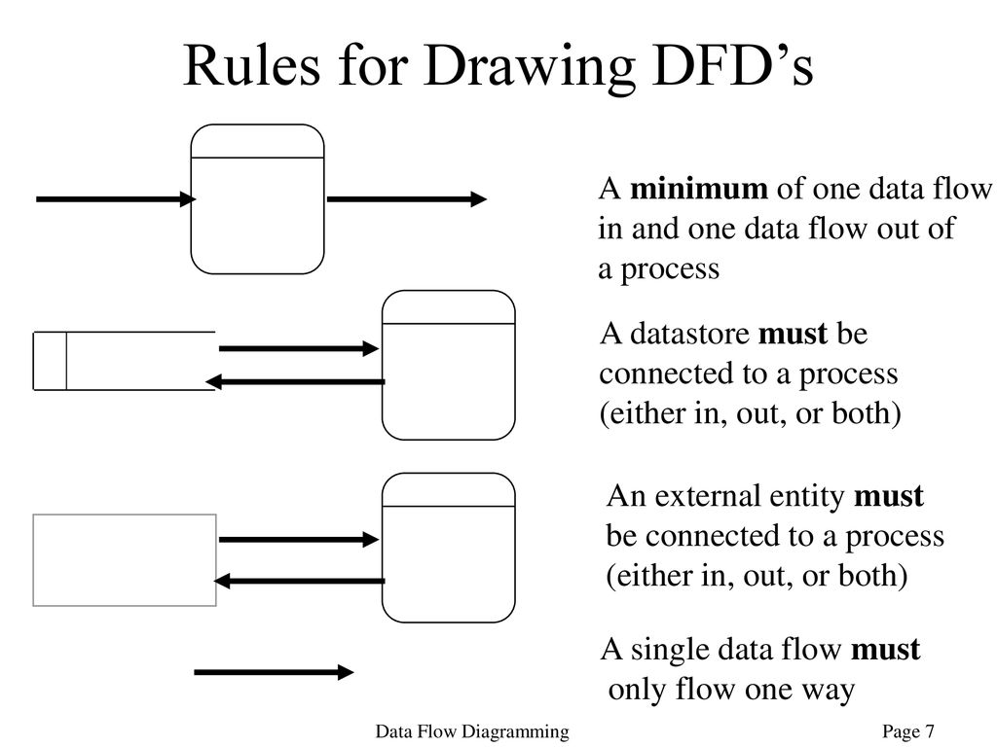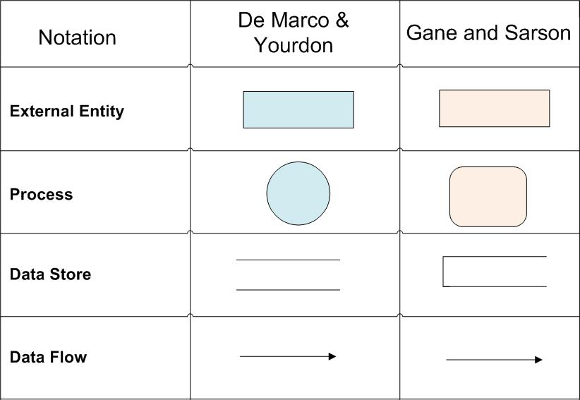

1. Level-0 DFD: Level-0 DFD shows the system’s major processes, data flows, and data stores at a high level of abstraction.
2. Level-1 DFD: Level-1 DFD shows the sub-processes of one of the processes in the Level-0 DFD.Generally, one level 1 diagram is created for every major process on the level 0 diagram.
3. Level-n DFD: Level-n DFD shows the sub-processes of one of the processes in the Level n-1 DFD. It shows all processes that comprise a single process on the level 1 diagram. It also shows how information moves from and to each of these processes.

**LOGICAL VS PHYSICAL DFDs**

* Data flow diagrams are categorized as either logical or physical. A logical data flow diagram focuses on the business and how the business operates. It is not concerned with how the system will be constructed.
* 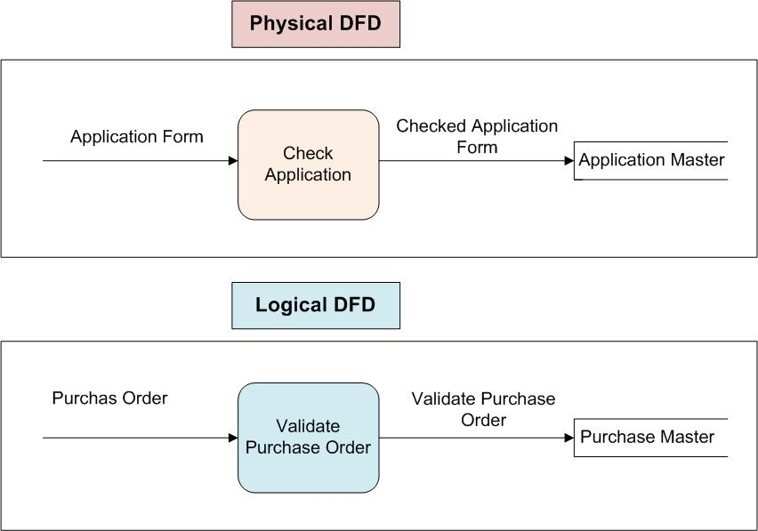A physical data flow diagram shows how the system will be implemented, including the hardware, software, files, and people in the system. It is developed such that the processes described in the logical data flow diagrams are implemented correctly to achieve the goal of the business.

**LOGICAL MODELLING**

* A logical data model establishes the structure of data elements and the relationships among them. It is independent of the physical database that details how the data will be implemented.
* The logical data model serves as a blueprint for used data. The logical data model takes the elements of conceptual data modeling a step further by adding more information to them.

1. STRUCTURED ENGLISH

* Structured English is used to describe the logic of a process. It is based on the principle of the structured programming.
* It is created by the merging of the English language with the syntax of the structured programming. It tries to express the verbal statement in the more logical form.

1. DECISION TREE

* A decision tree is a diagram that resembles a tree, with a root on the left hand side and branches representing each decision.
* It is read from left to right and the actions to be undertaken are recorded down the right hand side of the diagram.
* The root of the tree, on the left of the diagram is starting point of the decision sequence.

1. DECISION TABLE

* Decision tables are a method of describing the complex logical relationship in a precise manner which is easily understandable.
* It is useful in situations where the resulting actions depend on the occurrence of one or several combinations of independent conditions
* The entries in decision table are given by Decision Rules which define the relationships between combinations of conditions and courses of action.

**CONCEPTUAL DATA MODELLING**

* Conceptual Data Modeling Conceptual data model is a detailed model that captures the overall structure of data in an organization. It is independent of any database management system (DBMS) or other implementation considerations.
* Entity-Relationship (E-R) diagrams are commonly used to show how data are organized. The main goal of conceptual data modeling is to create accurate E-R diagrams.

ENTITY RELATIONSHIP MODELING

* E-R data model is a detailed, logical, and graphical representation of the entities, associations and data elements for an organization or business area.
* An entity-relationship diagram (or, E-R diagram) is a detailed, logical, and graphical representation of the data for an organization or business area. It is a graphical representation of an E-R model.

Entities

* An entity is a person, place, object, event or concept in the user environment about which the organization wishes to maintain data.
* Represented by Rectangle.

RAM

Attributes

* An attribute is a property or characteristic of an entity that is of interest to the organization.
* Represented by eclipse.

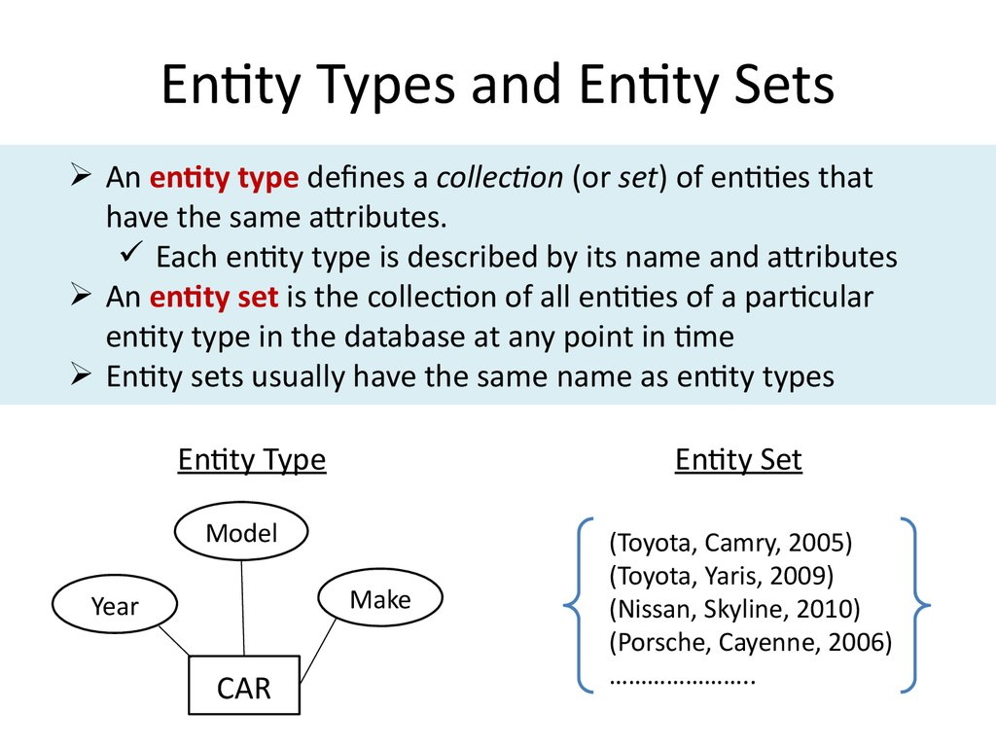

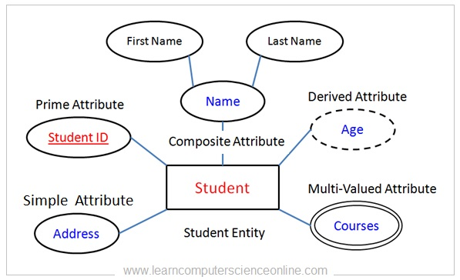**TYPES OF ATTRIBUTE**

**DEGREE OF RELATIONSHIP**

1. Unary Relationship

* 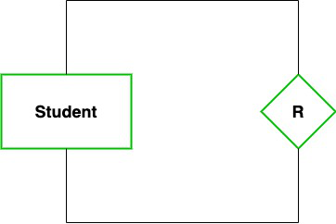A relation in which only one entity set participate then such type of relationship is known as a unary relationship.

1:1 UNARY RELATIONSHIP

1:1

Married to

PERSON

1: M UNARY RELATIONSHIP

1

Managed by

EMPLOYEE

M

M: N UNARY RELATIONSHIP

Prerequisite

Students

M: N

1. Binary Relationship

* 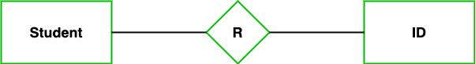 A relation when two entity sets are participating then such type of relationship is known as a binary relationship.

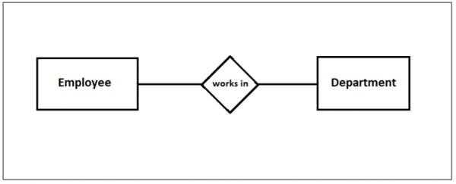1:1 BINARY

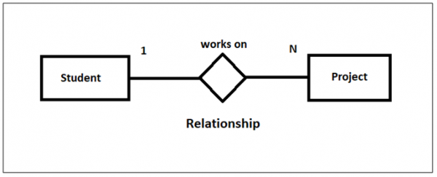1: M BINARY

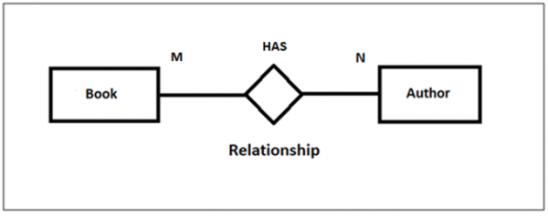M: N BINARY

1. N-ary relationship

* 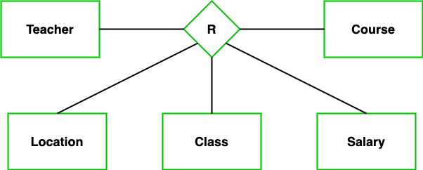In the N-ary relationship, there are n types of entity that associates. So, we can say that an N-ary relationship exists when there are n types of entities.

TOTAL PARTICIPATION

* 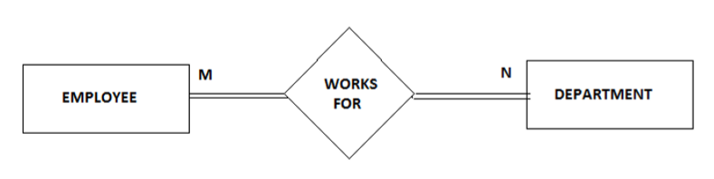Each entity in the entity set is involved in at least one relationship in a relationship set i.e. the number of relationship in every entity is involved is greater than 0.

PARTIAL PARTICIPATON

* 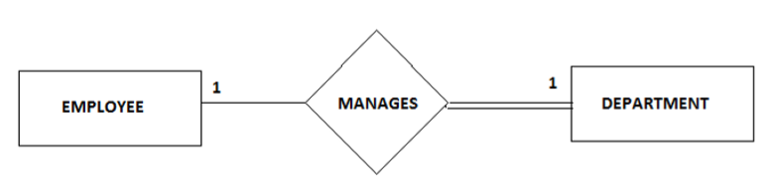Each entity in entity set may or may not occur in at least one relationship in a relationship set.